Supplementary Information

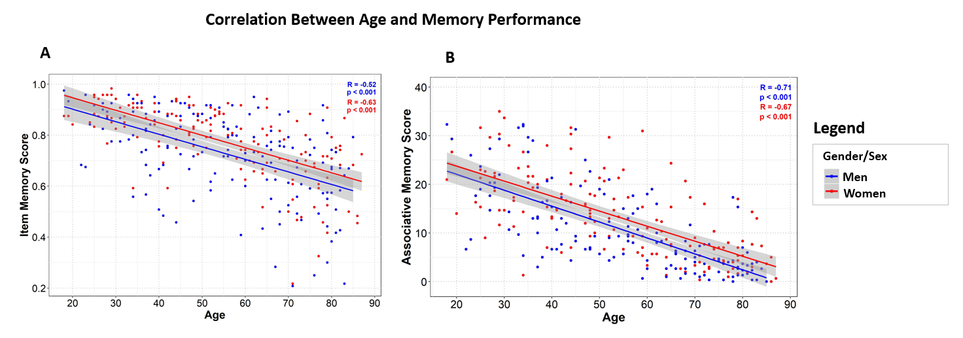
Figure S1: Correlation between age and memory performance. A) Item Memory score (% hits minus % false alarms). B) Associative Memory Score (number of background scenes correctly recalled). Memory scores represent the average score across valence of the background image (positive, neutral, and negative).

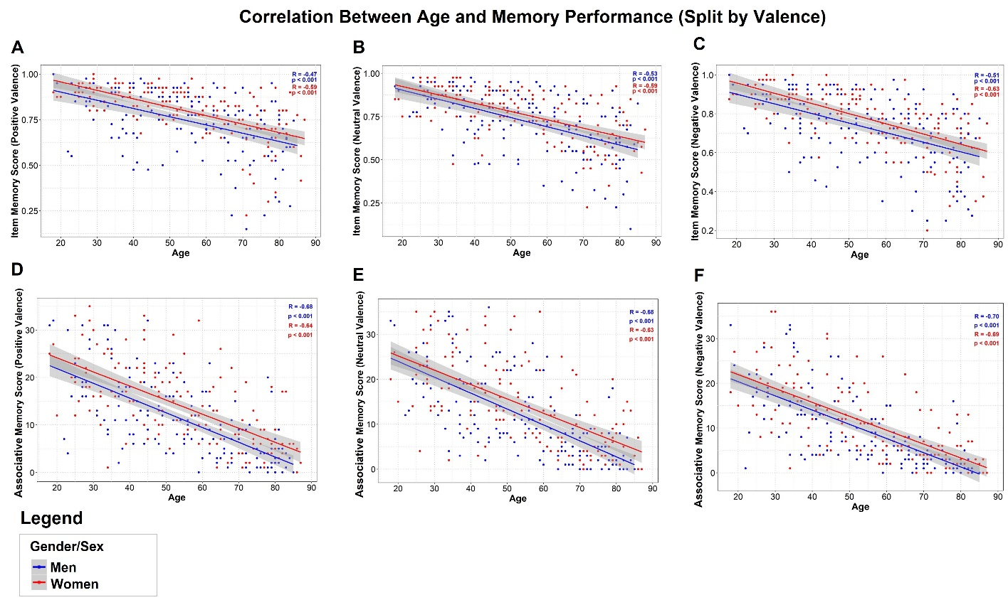
Figure S2: Correlation between age and memory performance split by valance of the background image. Top panel: Item Memory. Bottom panel: Association Memory.

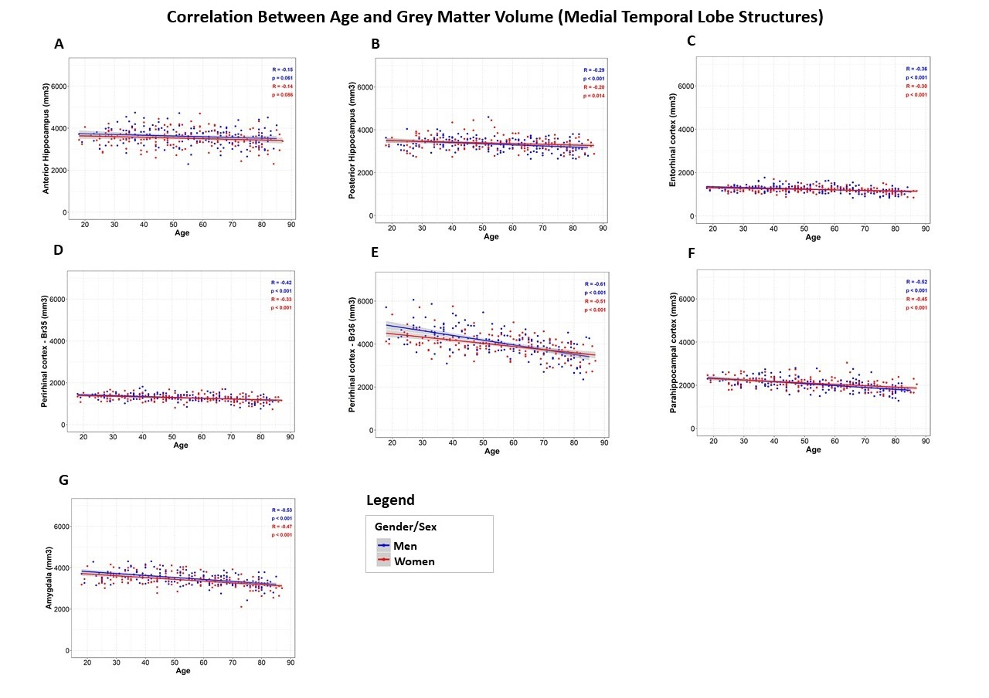
Figure S3: Correlation between age and grey matter volume in medial temporal lobe structures. A) Anterior hippocampus. B) Posterior hippocampus. C) Amygdala. D) Entorhinal cortex. E) Perirhinal cortex - Br35. F) Perirhinal cortex - Br36. G) Parahippocampal cortex. Volumes shown represent the sum of both left and right hemispheres. Plots for each hemisphere are shown below.

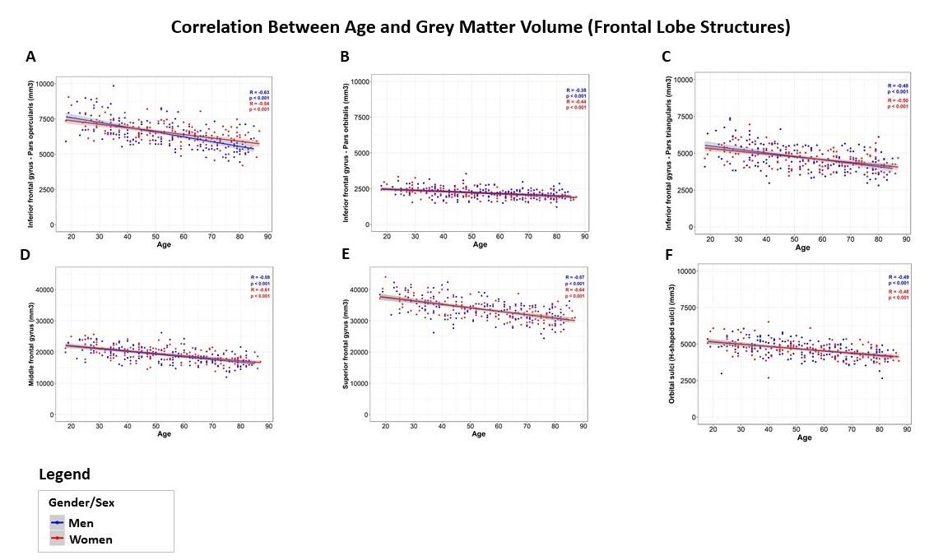
Figure S4: Correlation between age and grey matter volume in frontal lobe structures. A) Inferior frontal gyrus - Pars opercularis. B) Inferior frontal gyrus - Pars orbitalis. C) Inferior frontal gyrus - Pars triangularis. D) Middle frontal gyrus. E) Superior frontal gyrus. F) Orbital sulci (H-shaped sulci). Volumes shown represent the sum of both left and right hemispheres. Plots for each hemisphere are shown below.

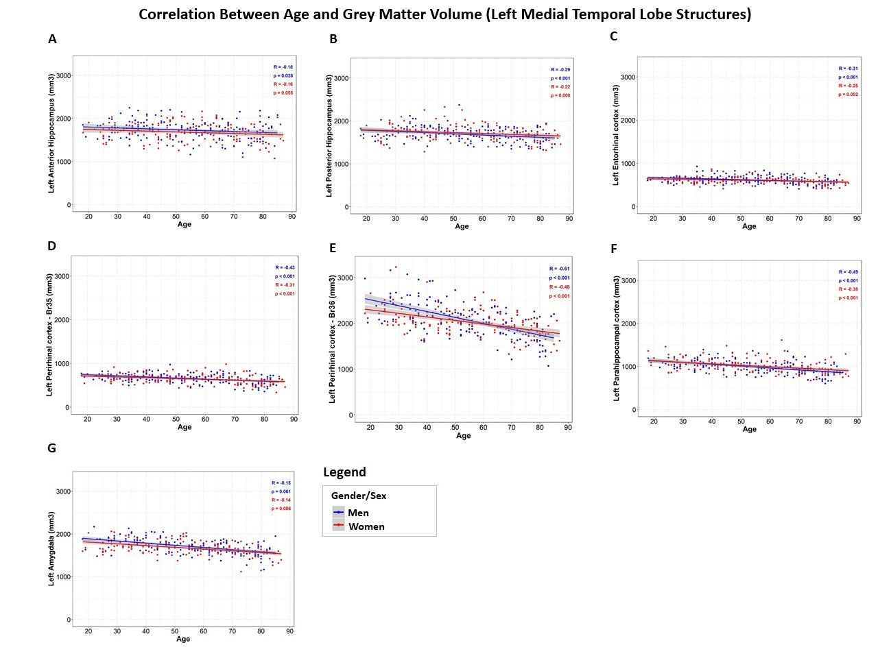
Figure S5: Correlation between age and grey matter volume (Left Medial Temporal Lobe Structures). A) Anterior hippocampus. B) Posterior hippocampus. C) Amygdala. D) Entorhinal cortex. E) Perirhinal cortex - Br35. F) Perirhinal cortex - Br36. G) Parahippocampal cortex.

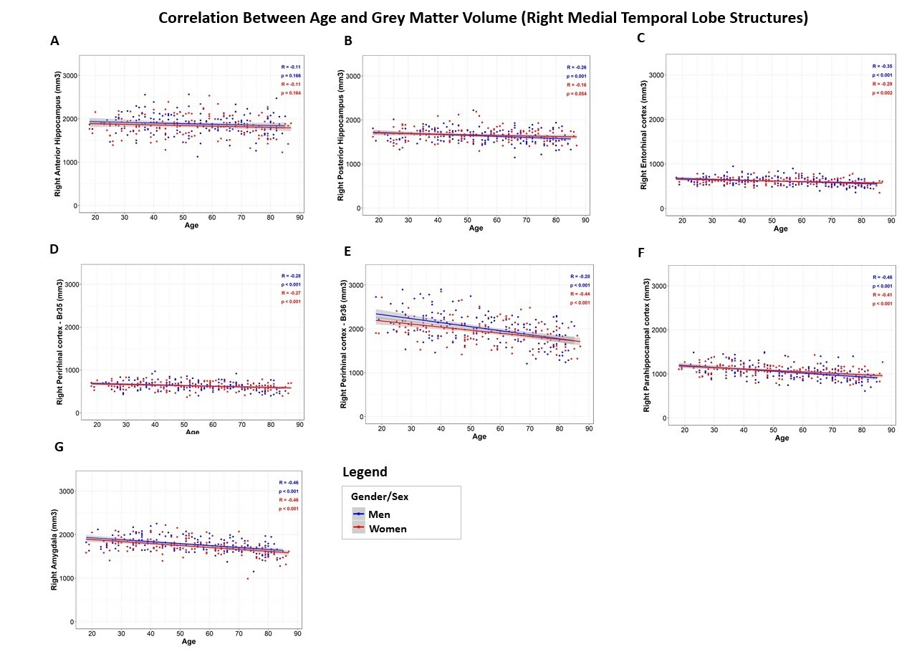
Figure S6: Correlation between age and grey matter volume (Right Medial Temporal Lobe Structures). A) Anterior hippocampus. B) Posterior hippocampus. C) Amygdala. D) Entorhinal cortex. E) Perirhinal cortex - Br35. F) Perirhinal cortex - Br36. G) Parahippocampal cortex.

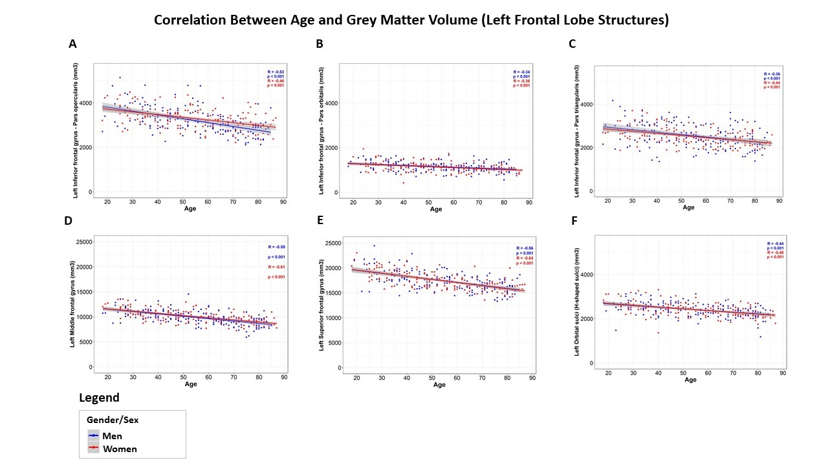

Figure S7: Correlation between age and grey matter volume (Left Frontal Lobe Structures). A) Inferior frontal gyrus - Pars opercularis. B) Inferior frontal gyrus - Pars orbitalis. C) Inferior frontal gyrus - Pars triangularis. D) Middle frontal gyrus. E) Superior frontal gyrus. F) Orbital sulci (H-shaped sulci).

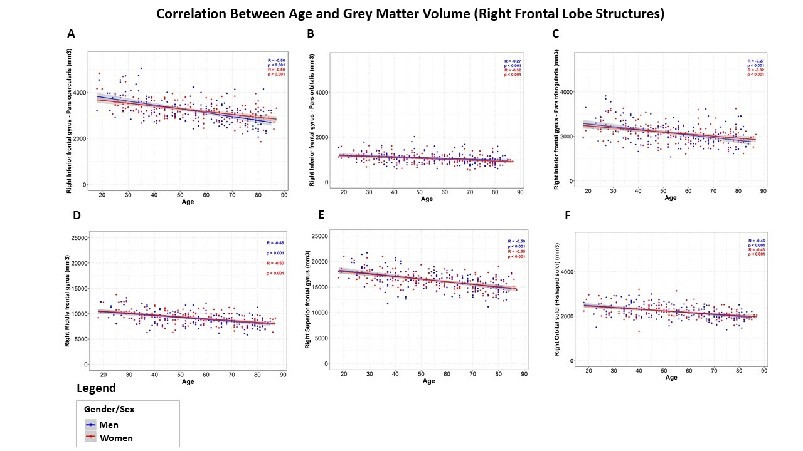

Figure S8: Correlation between age and grey matter volume (Right Frontal Lobe Structures). A) Inferior frontal gyrus - Pars opercularis. B) Inferior frontal gyrus - Pars orbitalis. C) Inferior frontal gyrus - Pars triangularis. D) Middle frontal gyrus. E) Superior frontal gyrus. F) Orbital sulci (H-shaped sulci).

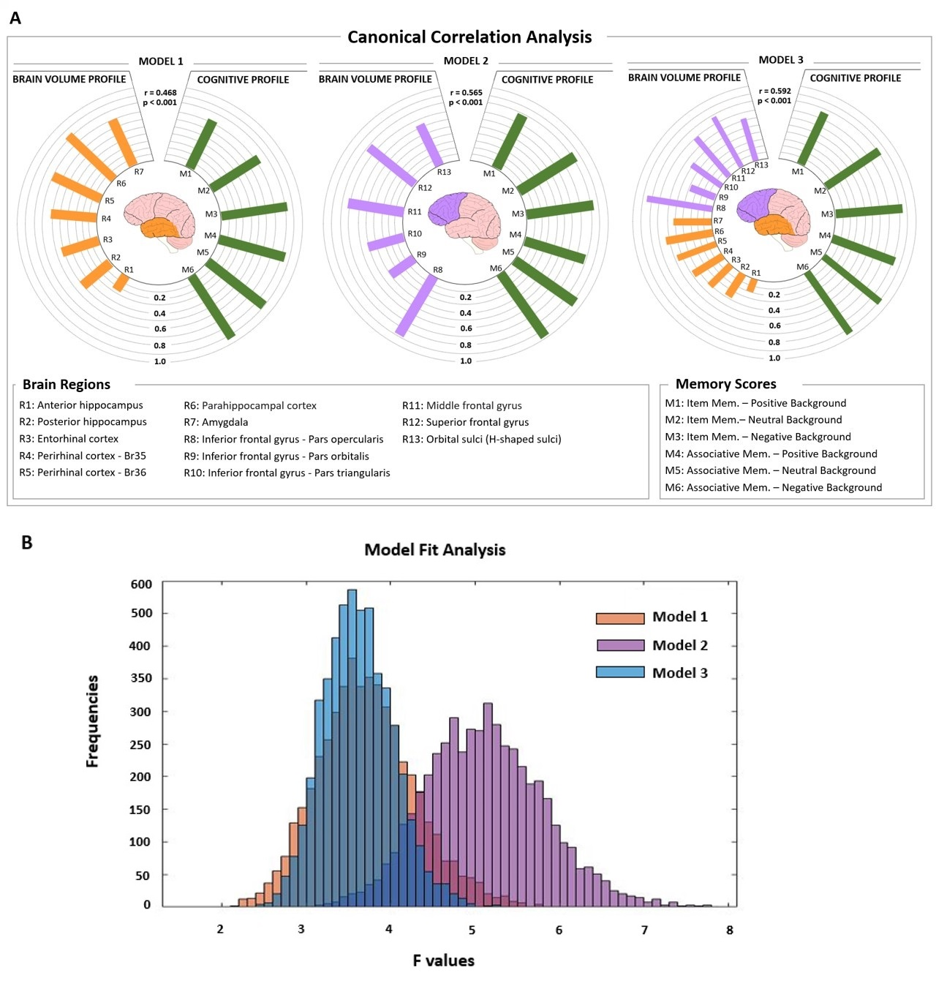
Figure S9: Canonical Correlation Analysis (CCA) - The relationship brain volumes and memory performance. A) Heliograph of variate loadings (correlations) for the first canonical variate, where the size of the correlations is indicated by the length of the bars. Item Memory scores (% Hits minus % False Alarms). Associative Memory scores (% Hits minus % False Alarms). The statistical relationships between brain structures (brain volume profile) and memory performance (cognitive profile) are for Model 1 (r = 0.468, p <0.001), for Model 2 (r = 0.565, p <0.001), and for Model 3 (r = 0.592, p <0.001). B) Model Fit Analysis (Bootstrapping approach). Histogram showing the frequencies of F values (5000 occurrences per model), representing the distribution of the ratio of explained variance to unexplained variance for each model. Results indicated that Model 2 (which included the frontal regions alone) predicted memory performance better than Model 1 (which included the medial temporal lobe regions alone), t = -128.79, p < 0.001, and better than Model 3 (which included both medial temporal and frontal regions), t = 230.49, p < 0.001. Further, Model 1, predicted memory performance better than Model 3, t = 18.54, p < 0.001.

Table S1 – Significance of the loadings of the CCA Model 2 – Associative Memory scores calculated as Percent Hits minus Percent False Alarms

CCA Component | Description | Loadings Scores
 |  | Mean | SD | 95% CI | p value
X  (Grey Matter Volume) | Inferior frontal gyrus - Pars opercularis | -0.0494 | 0.8809 | [-0.0738, -0.0245] | *0.012
 | Inferior frontal gyrus - Pars orbitalis | -0.0225 | 0.4270 | [-0.0343, -0.0106] | 0.356
 | Inferior frontal gyrus - Pars triangularis | -0.0272 | 0.5266 | [-0.0418, -0.0127] | 0.241
 | Middle frontal gyrus | -0.0405 | 0.7317 | [-0.06088, -0.0202] | 0.073
 | Superior frontal gyrus | -0.0454 | 0.7878 | [-0.0672, -0.0236] | *0.035
 | Orbital sulci (H-shaped sulci) | -0.0344 | 0.5863 | [-0.0506, -0.0181] | 0.140
Y  (Memory Scores) | Item Mem. – Positive Background | -0.0428 | 0.7510 | [-0.0636, -0.0219] | 0.052
 | Item Mem. – Neutral Background | -0.0442 | 0.7905 | [-0.0661, -0.0223] | *0.023
 | Item Mem. – Negative Background | -0.0446 | 0.7914 | [-0.0665, -0.0227] | *0.033
 | Associative Mem. – Positive Background | -0.0511 | 0.8931 | [-0.0759, -0.0265] | *0.032
 | Associative Mem. – Neutral Background | -0.0497 | 0.8733 | [-0.0739, -0.0255] | *0.003
 | Associative Mem. – Negative Background | -0.0534 | 0.9310 | [-0.0794, -0.0273] | *0.002

