Supplementary Information

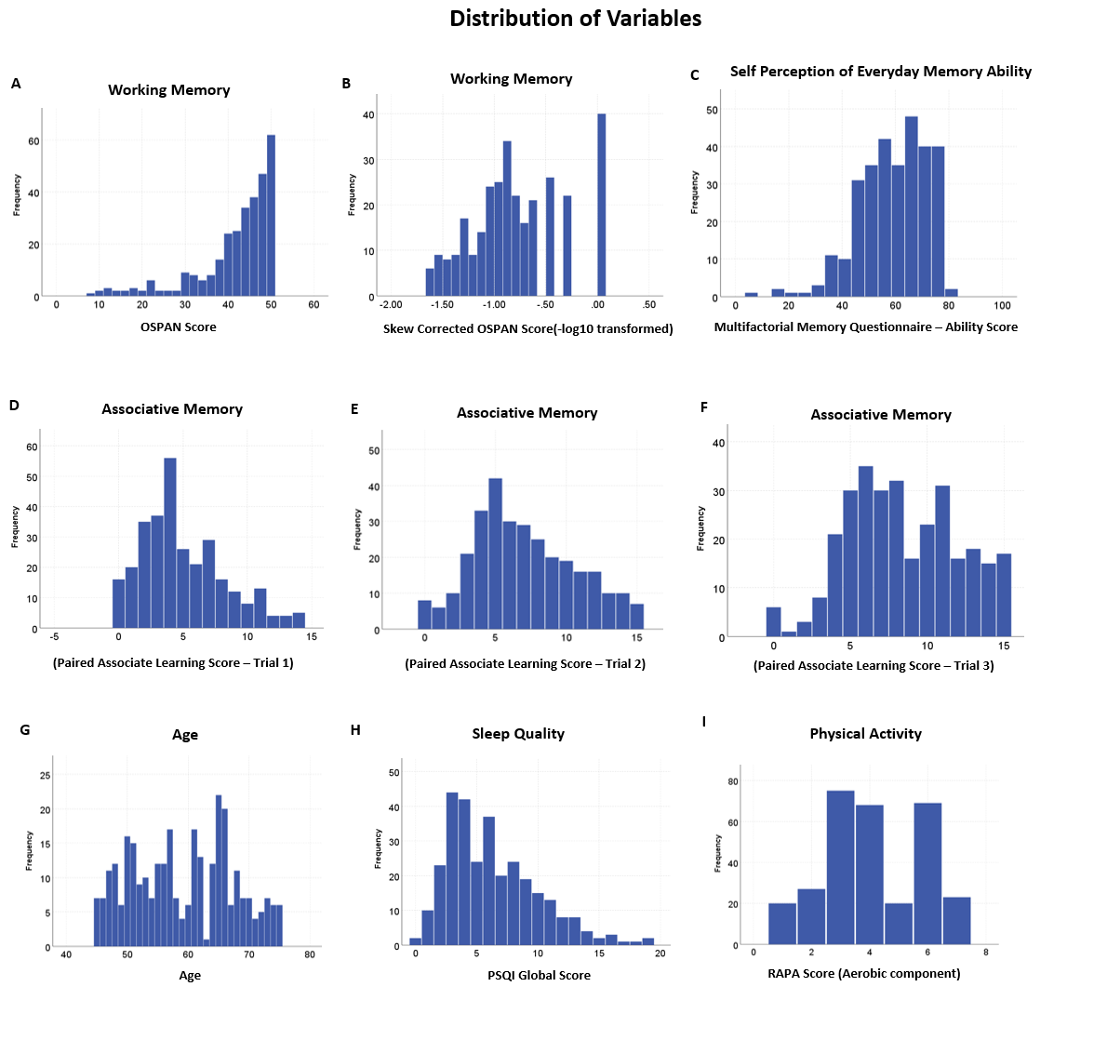
Figure S1 – Distribution of the variables used in the study. A) Working Memory – OSPAN score, B) Working Memory – Skew Corrected OSPAN score (-log10 transformed), C) Self-perception of everyday memory ability, D) Associative Memory – Paired Associative Learning score – Trial 1, E) Associative Memory – Paired Associative Learning score – Trial 2, F) Associative Memory – Paired Associative Learning score – Trial 3, G) Age, H) Sleep Quality – PSQI Global Score, I) Physical Activity – RAPA score.

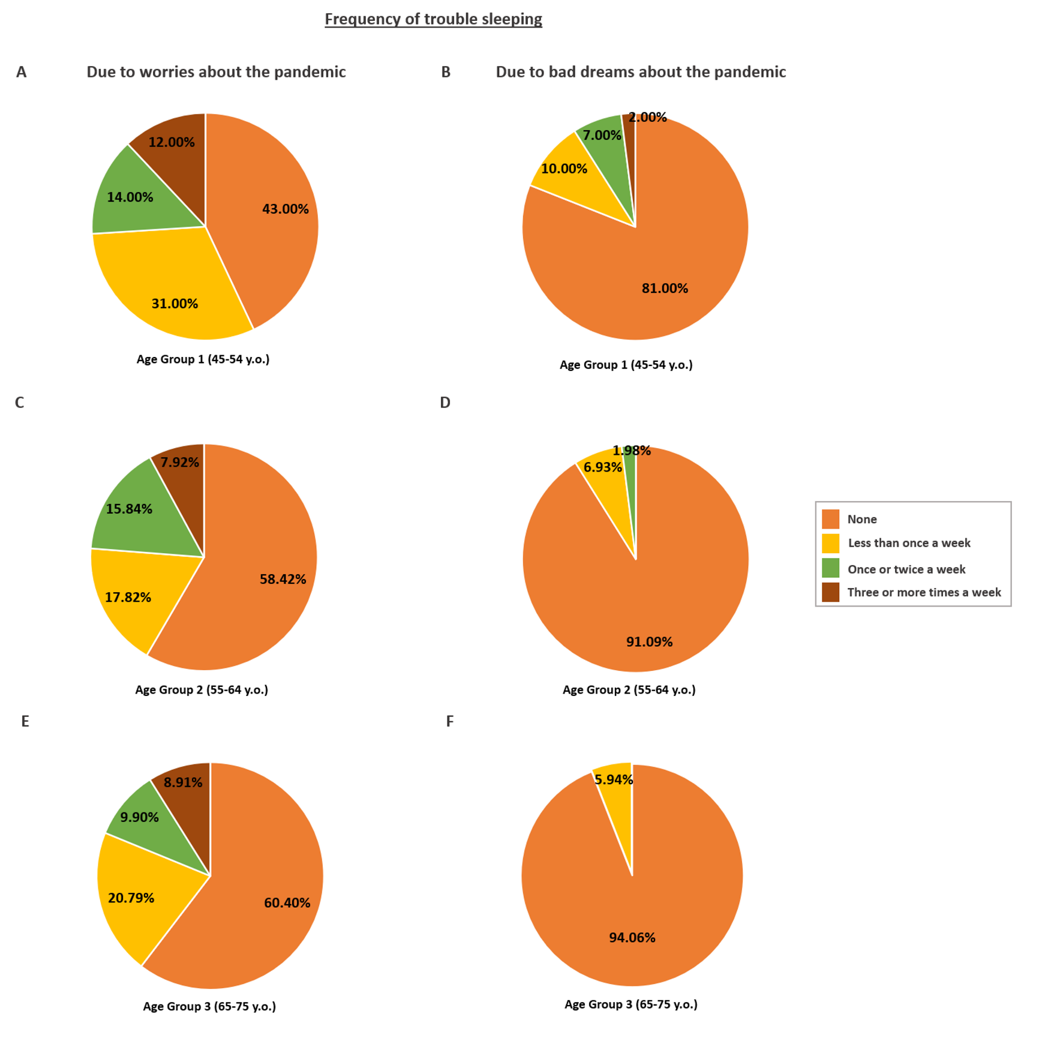
Figure S2 – Percentage of participants reporting that they were having trouble sleeping because of A) Worries about the pandemic and B) Bad dreams about the pandemic broken down by age groups for illustrative purposes (age was used a continuous variable in all analyses).

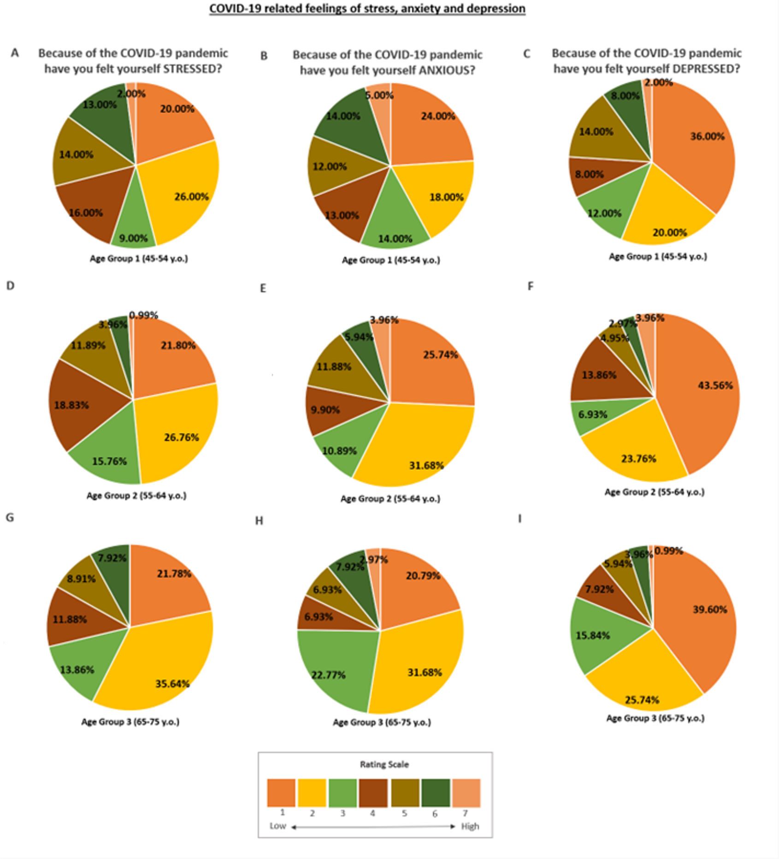
Figure S3 – Percentage of participants reporting each level of C) Stress, D) Anxiety, and E) Depression related to the pandemic broken down by age groups for illustrative purposes (age was used a continuous variable in all analyses).

